 | 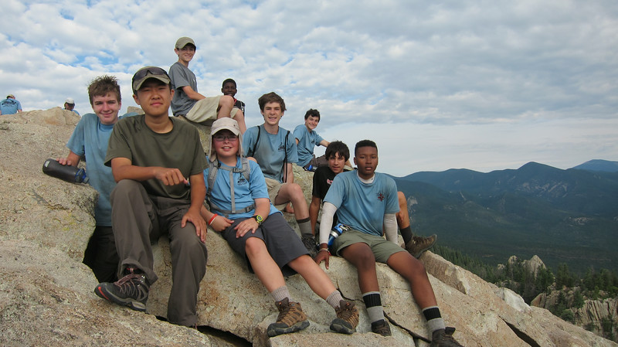
Hiking, Biking, Camping, Rafting, Kayaking, Canoeing, … Troop 631   | 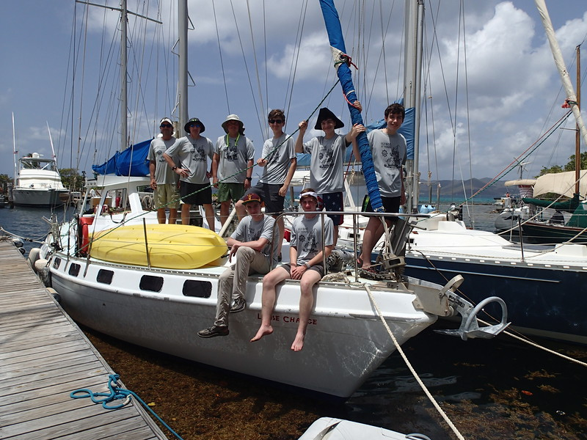
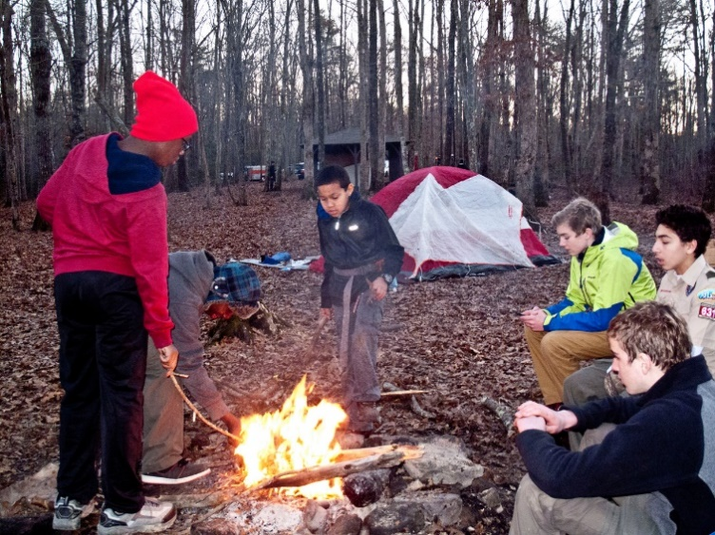  Twelve Month Program … What Do You Want to Do? | 
Planning Meeting – The Youth Plan it All  Saturday, August 15, 2015 – 9:30 to Noon  Middle School Cafeteria | Meetings at Woodward Middle School, 1655 Hardin Avenue, College Park, GA 30337, Most Mondays, 6:00 pm to 7:30  Contact: scoutmaster@atlanta631.mytroop.us  See: http://atlanta631.mytroop.us/

