
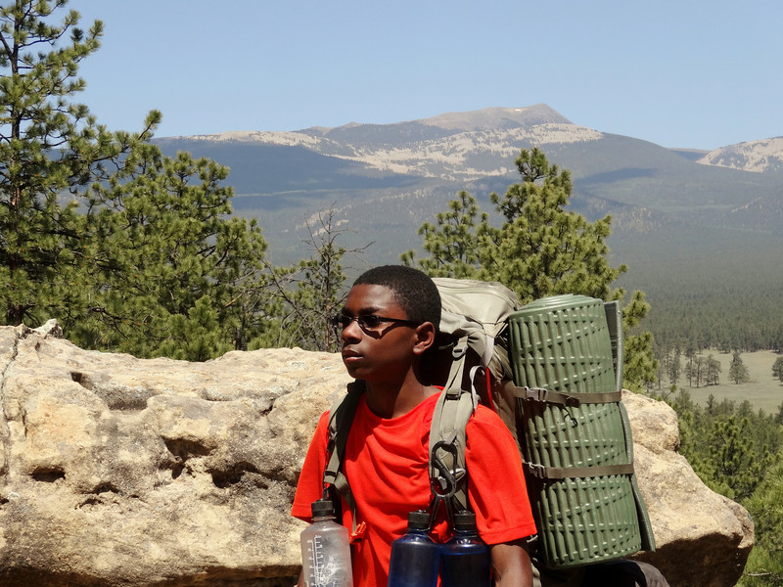
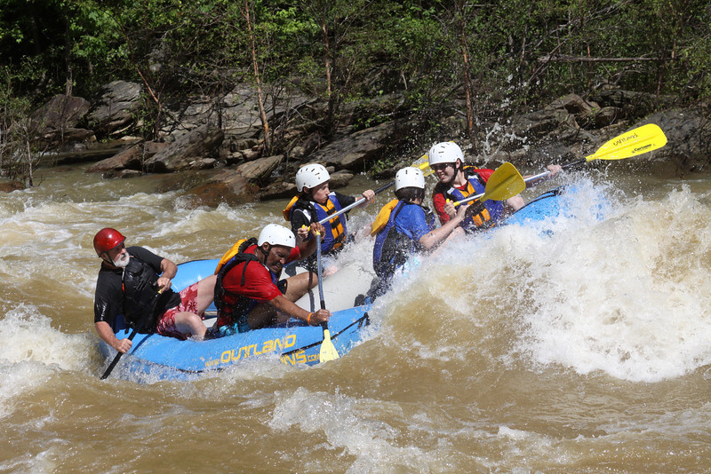
Subhead. Subhead. Subhead. Subhead.

Take a Wild Ride with Troop 631

Camping / Canoe Treks / Caving / Skiing / Biking / Backpacking / Climbing / Adventure / Rafting / Danger / Survival / Service
Next Highlights: Summer Camp in the Great Smoky Mountains / Camp Daniel Boone (June 8-14). And Kayaking / Rafting at the Summit in West Virginia. Backpacking at Philmont in New Mexico in July. Hiking and backpacking at Talullah Gorge March 21-23, and at Indian Springs/Dauset Trails April 25-27. Railroading back in time to Monticello, Charlottesville, VA May 2-4. Recent highlights: Okeefenokee Swamp Canoe Trek; Canoe Trek to Northern Tier / Canada in 2012; Space Camp Overnight; Ski Trek Weekend; Seabase in the Florida Keys; Cycling Campouts; Pine Mountain Backpacking; Chattahoochee River Canoe Trek; Black Rock Mountain Winter Camping; Climbing “Lock in” at Stone Summit; Polaris Winter Camp at Lawhorn Scout Reservation, Molena; Caving Campout (Tennessee); Zipline Campout (Helen, GA); Tallulah Gorge and High Falls State Park Camping; Allatoona Aquatic Base Canoe weekends (Northern Tier Prep); all that and community service too.
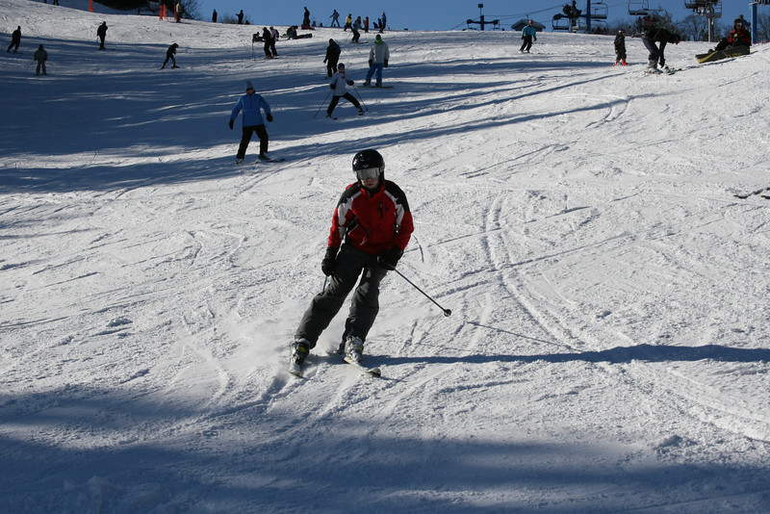

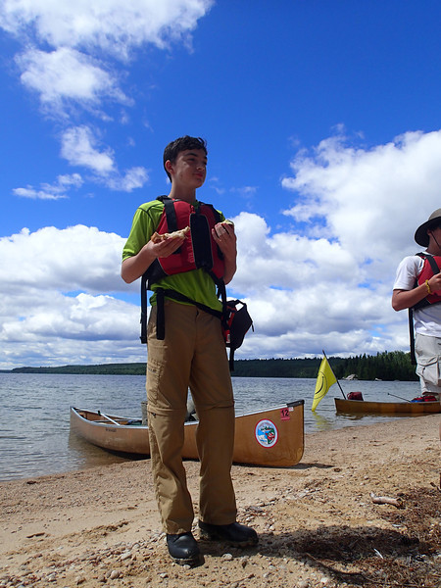

Top: Rafting in North Georgia and Philmont Trek, Northern New Mexico; Above: Skiing in North Carolina and Canoe Trek at Northern Tier

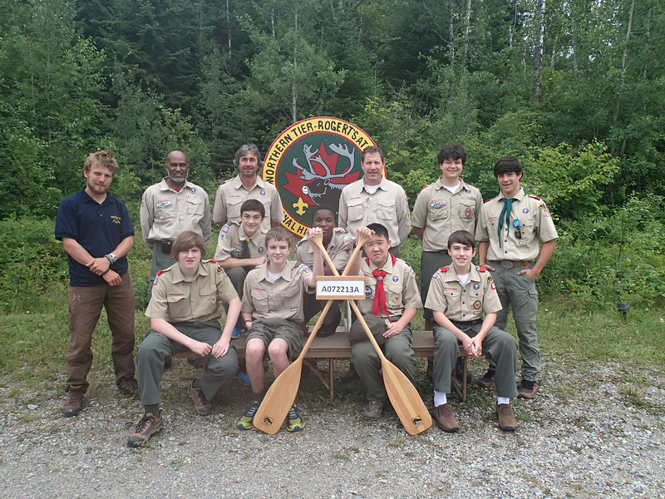
Troop 631

ph
fx

Sponsored by Wooward Academy
Meetings at Woodward Middle School
1655 Hardin Avenue, College Park, GA 30337
Most Mondays, 6:00 pm to 7:30
Contact: scoutmaster@atlanta631.mytroop.us
See: http://atlanta631.mytroop.us/

