  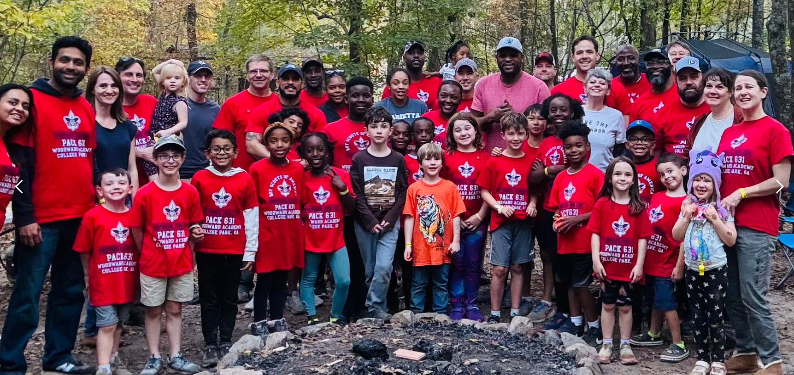
  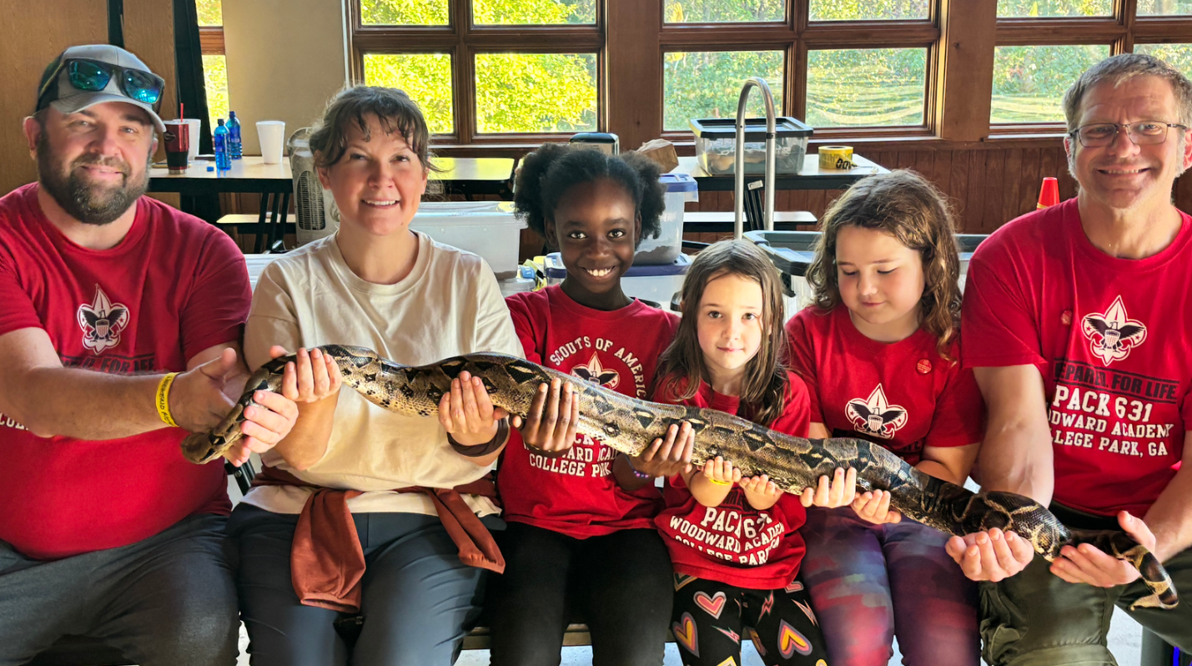
    - K Thru 5th Grade:
  Spring into ScoutS with Pack 631!
  We’re chartered by Woodward Academy -- Join Us!
  Cub Scouting is for families of Boys and Girls in Kindergarten through 5th Grade – and their families! – and you can join now!
  Join us in our fun activities for families …
  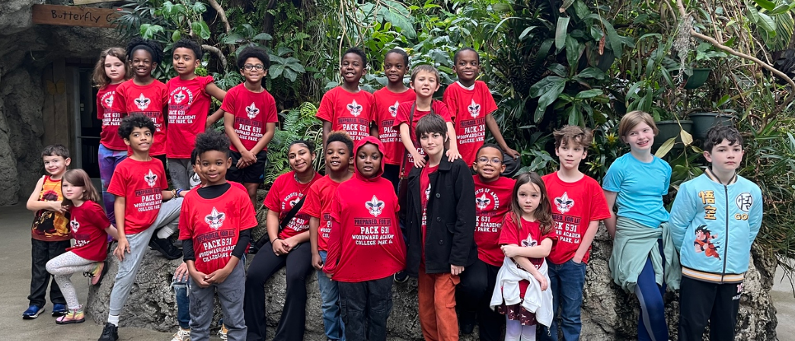
  Cub Scouting is Fun for Families!
  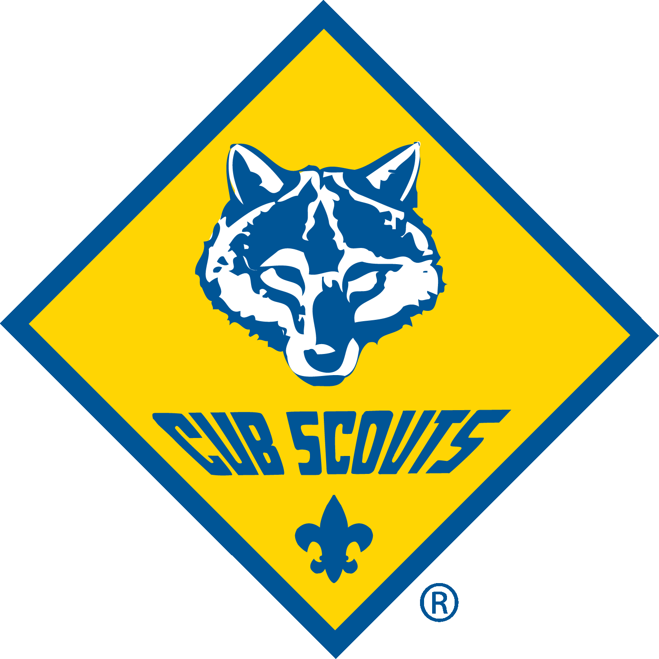
  What we do: biking, camping, hiking, racecars, fishing, sports, horses, BBs + archery, trips, fun, games, values, fun and fun
  Adventures and Character Building
  
  Click for More Info
Get Out and Cub Scout – With Pack 631!
Join Cub Scout Pack 631, sponsored by Woodward Academy -- Cub Scouting is for boys and girls in kindergarten through 5th grade who like adventure. You’ll be in the “Pack” … the Pack has smaller groups called “Dens” that are 6 to 8 (or so) Scouts in the same grade who do fun things together.
Quick Q&A About Cub Scouts:
Q: Isn’t Cub Scouts just for Boys?
A: Girls can be Cub Scouts! Since 2018, both girls + boys can join – our girls love Cub Scouting!
Q: When will Cub Scouts meet for adventures with their parent leaders in each grade?
A: When the families want to! Parents lead – parents decide! School days, weekends, or a mix.
Q: How often do Cub Scouts meet for those adventures?
A: It’s flexible – you meet as often as you want to! Most of our dens meet once a month, some meet more. There may be 2 or more dens at a grade meeting at different times.
Q: Who leads Cub Scouts?
A: Parents! Yes, you can do it … we can give you excellent training and great support materials. Each of you can be a Den Co-Leader or Assistant, and wise families arrange to share the load of leadership – and the joy of leading. You can do it – we will help! Your child will be proud of you.
Q: Does the Pack do any activities with all of the Scout Families in all of the Dens?
A: Yes … we have plans! Here's what parents are already planning for Cub Scouts in Pack 631 – more can be added if we want to* (and events will need leaders/helpers):
- Come to our Welcome Back Pool Party August 22 and bring other families and friends!
- We’re going to Scout Day at the Braves August 29 (and we’ll parade around the field).
- Who wants to watch the Dragon Con Parade Saturday, Sept. 5 in Downtown Atlanta?
- All aboard the USS Yorktown in Charleston for an Aircraft Carrier Overnighter Sept. 19!
- Camping? Yes please! At the Fall Festival Campout October 16-18 at Bert Adams Scout Camp south of Covington, GA. (Or come out early Saturday.)
- We’ll learn about our State with a visit to the Chief Vann House in Chatworth (November)
- Honor those who served as part of Wreaths Across America December 19.
- A Day On, Not A Day Off: MLK Day Service Project January 18, 2027.
- Downhill Racers! Let’s Ski Maggie Valley (or learn to ski) February 13-15.
- Our annual Pinewood Derby (model car racing – maybe an Adult Race too?) February 20
- Let’s do the Civil Rights Heritage Hike with other Atlanta Scouts in March
- More camping and hiking and biking and horseback rides and fun stuff and more … Scout and Leader Recognition at the “Blue & Gold Awards Banquet” in April
For more info, please contact Cubmaster Steve Rodgers at 404.441.3904 or at srodgers@hksinc.com or Pack Trainer Bert Bender at 404.307.9403 bert.bender@alston.com or see this QR code and we’ll be in touch  (* dates and activities are subject to change + need organizers from among our families; got an idea for more fun? We can add more events!) | 

