  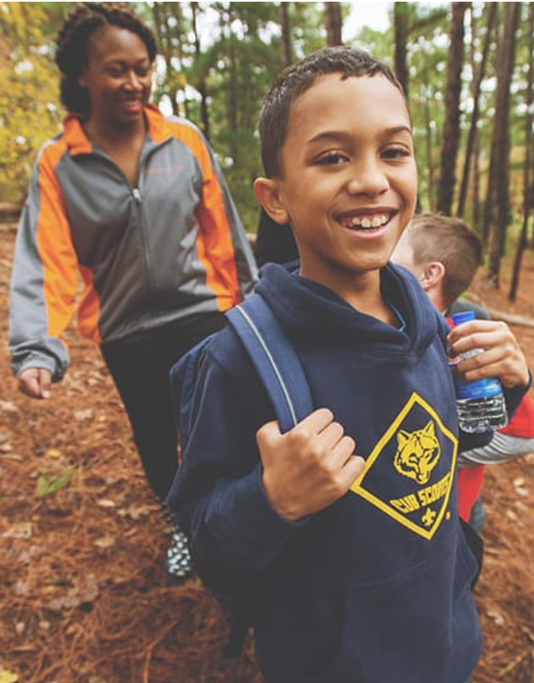
  K Thru 5th Grade:
  FUN WITH Cub Scout Pack ___
  We’re chartered by ___________ -- Join Us!
  Cub Scouting is for families of Kindergarten through 5th Grade Boys and Girls – and their families! – you can join now!
  Join us in our fun activities for families …
  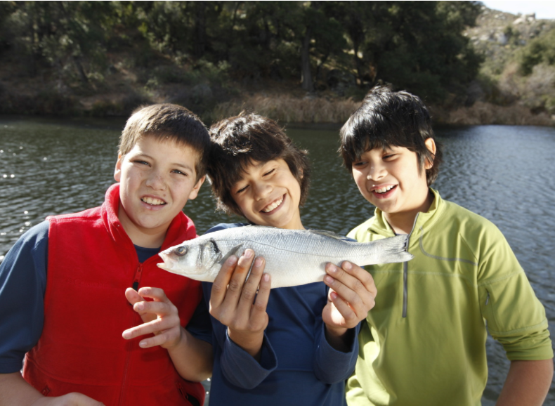
  Cub Scouting is Fun for Families!
  What we do: fun, racecars, biking, hiking, swimming, camping, fishing, cooking, fun, sports, slinghots / BBs / archery, field trips, fun, games, fun and fun
  Adventures for Kids and Families
  
  Want More Info??
  Contact ________ at ___.___.____ or at _______@_______
  or ________ at ___.___.____ or at _______@_______
Fun, Family, Friends and Adventure – Join our Cub Scout Pack!
Cub Scout Pack ____, chartered by ____________, is for boys and girls in Kindergarten through 5th Grade who like adventure fun with family and friends. A “Pack” has “Dens” of Scouts in the same grade (ideally 6 to 8, not more than 10) who do fun Adventures together, led by a team of parent leaders.
Every Scout can get a Handbook of Adventures and every family will receive lots of resources to bring the program to life as parent leaders lead their Scouts and Dens in those Adventures.
Here's some of the fun things that Cub Scouts in our Pack can do over the next year*:
District Cub Scout Day Camp Mon.-Fri., June 1-5 at ______________!
Kickball + Cookout on Saturday June 13 at ______________!
Splash + Swim on Saturday June 27 at ______________!
Let’s go Biking Back to the Pack on Saturday July 18 at ______________!
A Welcome Back to the Pack Pool Party on Saturday August 1 at the ______________ lifeguarded pool, starting at __:00 _.m., and we’ll all celebrate being “back to school – in the pool”!
Let’s do a Water Rocket Launch and Pack Cookout on Saturday August 15 at ______________!
What’s more fun than Scout Night with your World Champion Atlanta Braves at Truist Park, Saturday, ________ – Scouts and Leaders parade around the field before the game, then … go Braves!
Yes, let’s do it – attend the DragonCon Parade in downtown Atlanta Saturday, September 5
Walk in the Woods hike day at Atlanta’s Westside Reservoir Park on Sept. 19, starting at __:00 _.m.
Let’s do a Trailblazer Day at Bert Adams Scout Camp south of Covington, GA October 3.
Then we’ll do Our Big Spooky Ree Weekend Campout at Bert Adams Scout Camp October 23 to 25!
Celebrate our Vets at the Veterans Day Parade in midtown ATL on Saturday, November 7.
Sleep with the fishes at a Georgia Aquarium Sleepover Overnight on Saturday, November 14.
Service and Celebrate! We’ll do a Service Project December 12, with a party afterwards.
Start Your Engines! Pack Pinewood Derby, on Saturday, January 23, 2027.
Celebrate the Anniversary of Scouting with a Scouting for Food Drive, on Saturday, February 6, 2027 and Scout Sunday / Sabbath / Jumu’ah programs in February.
All Aboard the Aircraft Carrier at Patriot’s Point, Charleston, SC, February 26-28, 2027.
Civil Rights Heritage Hike March 20, 2027, starting at Ebenezer Baptist Church.
We will go Spring Camping April 16-18, 2027, at a new (to us!) camp to be selected.
Join our “Blue & Gold Awards Banquet” to recognize Scouts and Leaders, Friday, May 7, 2027
Fishing Derby Fun Day, May 15, 2027, at Sweetwater Creek State Park!
We can go to one or more Cub Scout Day or Twilight Camps in June.
June 12: Kites and Cookout. June 26: Splash and Swim.
Each grade level Den will have additional activities organized by parent leaders, doing what the Den families want to do as they Get Out and Cub Scout!
(* dates and activities may change + need organizers; more may be added!)  For more info, or to join, please contact _________ at ___.___.____ or _______@_____ (or ______ at ___.___.____ or _______@______)  Or Scan this QR to receive an email or website access and more Information | Paste  Your  QR Code  Here

