Membership Meeting
February 4, 2026
Supporting the Mission of the Atlanta Area Council’s Programs:
Stronger Families through Scouting
- Kickoff and Introductions (7:00 p.m.): Invitees are District and Council professionals and volunteers engaged in supporting units with their recruiting and retention efforts.
- Bert Bender, Council Recruiting Coordinator/Volunteer; Richard Fallon, Staff Advisor/Field Director
- District Membership Teams: updates requested to be sent to bert.bender@alston.com
- Welcome from Doug Turner, Council Vice President of Membership
- Most Important Topics? Issues/questions/concerns from attendees. Could be:
- Do we continue with the Six Steps for Successful and Sustainable Recruiting?
- Build your Calendar of Activities – what Units will do year-round.
- Promote Your Unit and those activities. Not just by leaders – by parents too!
- Recruit More Leaders – one by one, turning parents into helpers and helpers into leaders.
- Build School and Community Presence – connections including service like “Adopt a School”.
- Hold Joining Events, both Fun Joining Events (done by the Unit as you like) and School Sign Up Nights (professionally coached at back-to-school time)
- More Fun Activities. Any fun activity can be a welcoming joining event.
- Feedback on the “In Emergency Break Glass Guide to Our School Won’t Give Us Access” Plan?
- Ideas for Improvement, focus, implementation?
- Scouts BSA and Venturing Steps. Do those same steps work in those units … but with Scouts themselves taking more of a role for “peer to peer” recruiting?
- New Unit Process – Richard Fallon, for Chad Duncan, AAC New Unit Chair
- New Unit Plan being implemented with Field Staff
- Does This Plan Make Sense? Unit Centered – “Right Sized” and Year-Round – Recruiting
- Recruit to fit Pack Resources (especially engaged leaders)  - Use Spring to Get more Leaders.  - Cub Leader Factor: recruit one new Adult Leader for every five new Youth  - Spoiler: Recruiting 100 youth into a Pack with 5 leaders is failure  - Seasonal Recruiting Concept:  - Spring/Summer Simple Scouting Recruiting  - Back to School Recruiting (with School Sign Up Nights)  - Winter Retention – program support to retain and add more.  - Teams. District Teams to work with Units with “Spring” Check-Ins and Start of Summer “Fall Recruiting” Check-Ins | 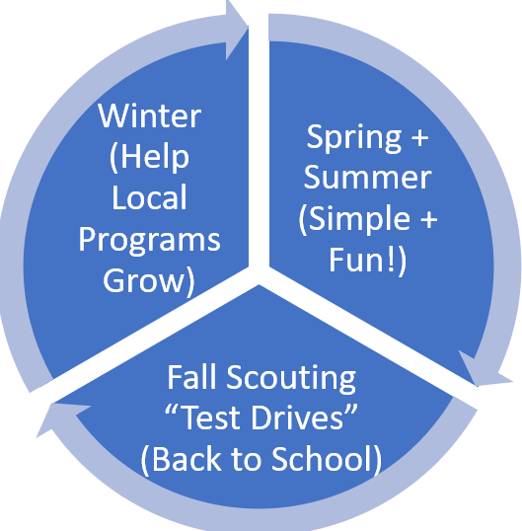
- Supplies, Swag, Baubles and Gewgaws. Richard Fallon.
- Inflatable BB Gun Range at VSC (during back to school shopping hours)
- Backpacks with Goodies for Sign Up Nights (slime, stickers)
- 100 Dutch Ovens as incentives for strong recruiting performance
- More Feather Banners
- Handbooks are back
- New teacher gifts -dry erase marker packs with the phrase: “Scouting makes remarkable students”
- Spring and Summer Recruiting? Unit Directed + Unit Driven – District Supports and Encourages
- Empower Packs! – not Professional-organized School Signups.  - The words “not Professional-organized School Signups” does not mean Professionals have no role  - Professional role: support District Volunteers to get the word out to District Packs and Dens about Spring and Summer Recruiting  - Spring and Summer Recruiting Concept: Encourage Packs and Dens to do fun activities and invite others to join  - Encourage Simple Scouting: “Fun * Simple * Easy” Activities  - Easier for leaders … and allows current leaders to induce more parents to help and lead in the coming program year  - Spring and Summer Joining can be a foundation for fall recruiting. | 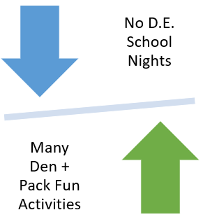
- Dens and Packs that have “Fun * Simple * Easy” Activities are more likely to build a program with a robust calendar of activities that families next fall want to join - even in spring and summer.
- Tools and Resources for Districts Coaching Unit Volunteers. scoutingatl.org/MembershipTools What else would we like to develop?
- “Best Practices” for Sign Up Events Session/Video (align with script/align script)
- Social Media Use by Pack Parents and Troop Scouts
- Local Pack Video Creation?
- The Retention Issue. Richard Fallon and Bert
- Open discussion on what we see and how we can improve.
- Cross-Council Coordination – Working with Other Committees/Support Groups:
- Commissioners need to know how to recruit and connect units to resources like scoutingatl.org/recruitingresources
- Training (how to connect new leader/helper prospects to training)
- Field Staff Pros (support of “unit driven” efforts; unit and district coordination with VSC processes)
- Marketing (website, arc of messaging, support)
- Other? _____
- Data. Are Your Membership Teams Seeing District Tools (Application Manager/Invitation Manager)?
- Future Meeting Dates.
- Breakouts (April, July, etc.)
- Summer Kickoff Rally
- Other
- Feedback … What Else – What Did We Miss.

